EXPERIMENT NO. 12
AIM
To write an Embedded C program to multiply two 16-bit numbers using Keil software.
ALGORITHM
- Declare two 16-bit unsigned integers and one 32-bit product variable.
- Assign the two input values.
- Multiply the two 16-bit numbers and store the 32-bit result.
- Send the four bytes of the result to Ports P0, P1, P2 and P3.
- Repeat continuously.
PROGRAM
#include <reg51.h>
void main()
{
while(1)
{
unsigned int num1, num2;
unsigned long int product;
num1 = 0x2222;
num2 = 0xBBBB;
product = (unsigned long int)num1 * num2;
P0 = product & 0xFF;
P1 = (product & 0xFF00) >> 8;
P2 = (product & 0xFF0000) >> 16;
P3 = (product & 0xFF000000) >> 24;
}
}
OUTPUT
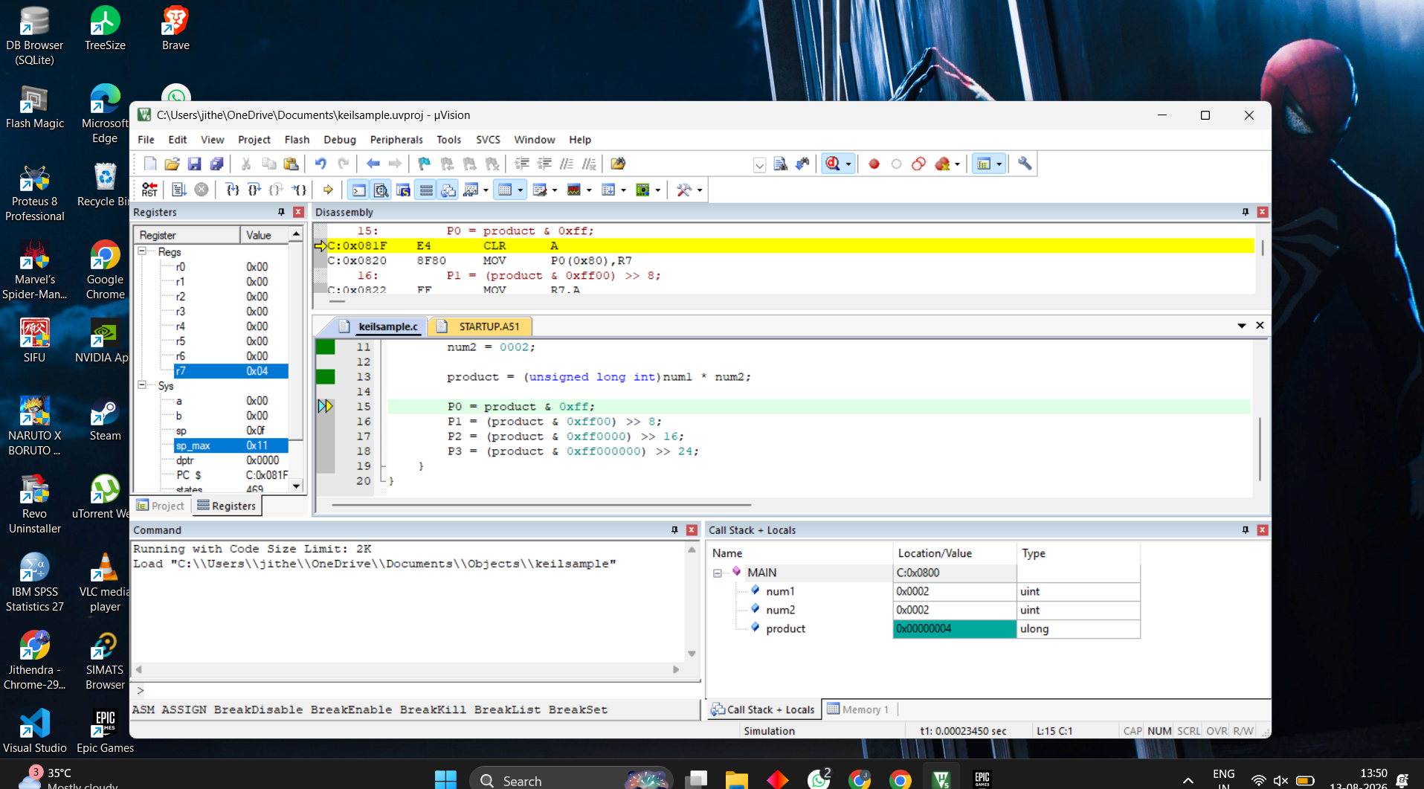
RESULT
Thus the program has been successfully verified and executed.

